Assignment 3
Snippet 1:
public class InfiniteForLoop {
public static void main(String[] args) {
for (int i = 0; i < 10; i--) {
System.out.println(i);
}
}
}
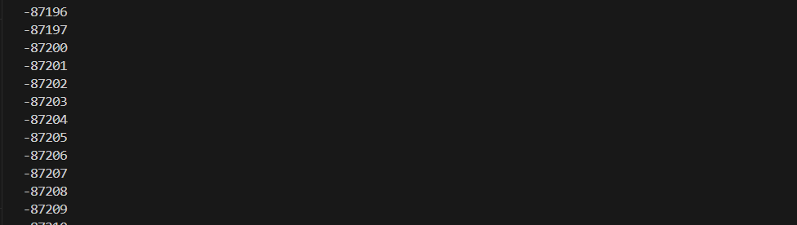
public class InfiniteForLoop {
public static void main(String[] args) {
for (int i = 0; i < 10; i++) {
System.out.println(i);
}
}
}

The loop control condition is i < 10, meaning the loop should run as long as i is less than 10.

Snippet 2:
public class IncorrectWhileCondition {
public static void main(String[] args) {
int count = 5;
while (count = 0) {
System.out.println(count);
count--;
}
}
}
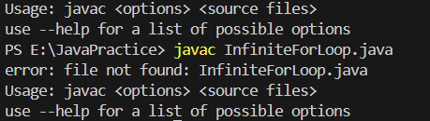

Snippet 3:
public class DoWhileIncorrectCondition {
public static void main(String[] args) {
int num = 0;
do {
System.out.println(num);
num++;
} while (num > 0);
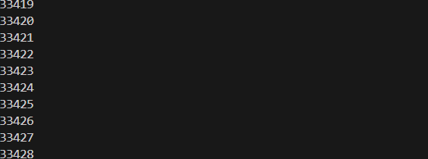

public class DoWhileIncorrectCondition
{
public static void main(String[] args) {
int num = 0;
do {
System.out.println(num);
num--;
} while (num > 0);
}
}
Reason:-
Snippet 4:
public class OffByOneErrorForLoop {
public static void main(String[] args) {
for (int i = 1; i <= 10; i++) {
System.out.println(i);
}
// Expected: 10 iterations with numbers 1 to 10
// Actual: Prints numbers 1 to 10, but the task expected only 1 to 9
}
}

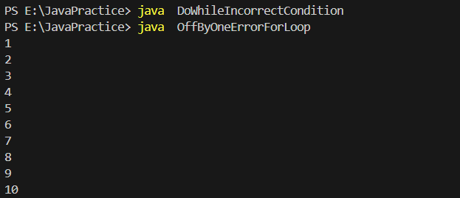

public class OffByOneErrorForLoop {
public static void main(String[] args) {
for (int i = 1; i <= 9; i++) {
System.out.println(i);
}
}
}
Reason:

Snippet 5:
public class WrongInitializationForLoop {
public static void main(String[] args) {
for (int i = 10; i >= 0; i++) {
System.out.println(i);
}
}
}

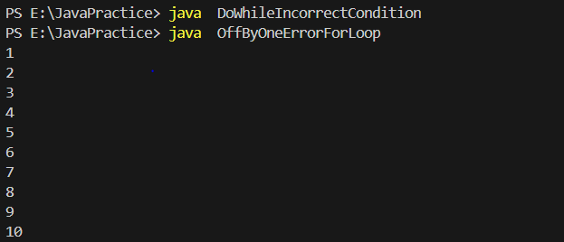

public class WrongInitializationForLoop {
public static void main(String[] args) {
for (int i = 0; i <= 10; i++) {
System.out.println(i);
}
}
}
Reason:-
Snippet 6:
public class MisplacedForLoopBody {
public static void main(String[] args) {
for (int i = 0; i < 5; i++)
System.out.println(i);
System.out.println("Done");
}
}

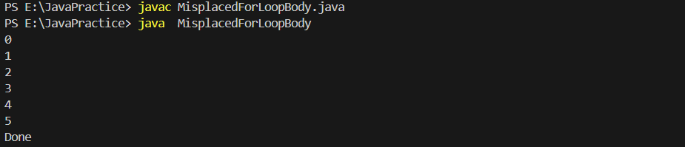

public class MisplacedForLoopBody {
public static void main(String[] args) {
for (int i = 0; i <= 5; i++){
System.out.println(i);
System.out.println("Done");

}

}
}

Reason:---

Snippet 7:
public class UninitializedWhileLoop {
public static void main(String[] args) {
int count;
while (count < 10) {
System.out.println(count);
count++;
}
}
}

public class UninitializedWhileLoop {
public static void main(String[] args) {
int count = 0;
while (count < 10) {
System.out.println(count);
count++;
}
}
}
Reason:-

Snippet 8:
public class OffByOneDoWhileLoop {
public static void main(String[] args) {
int num = 1;
do {
System.out.println(num);
num--;
} while (num > 0);
}
}
public class OffByOneDoWhileLoop {
public static void main(String[] args) {
int num = 1;
do {
System.out.println(num);
num++;
} while (num <= 5);
}
}

Snippet 9:
public class InfiniteForLoopUpdate {
public static void main(String[] args) {
for (int i = 0; i < 5; i += 2) {
System.out.println(i);
}
}
}
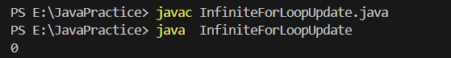

public class InfiniteForLoopUpdate {
public static void main(String[] args) {
for (int i = 0; i <= 5; i += 1) {
System.out.println(i);
}
}
}
Reason:-

Snippet 10:
public class IncorrectWhileLoopControl {
public static void main(String[] args) {
int num = 10;
while (num = 10) {
System.out.println(num);
num--;
}
}
}

public class IncorrectWhileLoopControl {
public static void main(String[] args) {
int num = 10;
while (num >= 10) {
System.out.println(num);
num--;
}
}
}
Reason:-

Snippet 11:
public class IncorrectLoopUpdate {
public static void main(String[] args) {
int i = 0;
while (i < 5) {
System.out.println(i);
i += 2; // Error: This may cause unexpected results in output
}
}
}
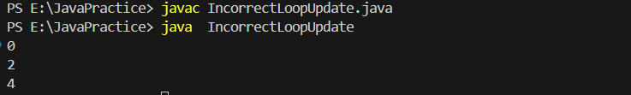

public class IncorrectLoopUpdate {
public static void main(String[] args) {
int i = 0;
while (i < 5) {
System.out.println(i);
i += 1; // Error: This may cause unexpected results in output
}
}
}
Reason:-

Snippet 12
public class LoopVariableScope {
public static void main(String[] args) {
for (int i = 0; i < 5; i++) {
int x = i * 2;
}
System.out.println(x); // Error: 'x' is not accessible here
}
}
// Error to investigate: Why does the variable 'x' cause a compilation error? How does scope

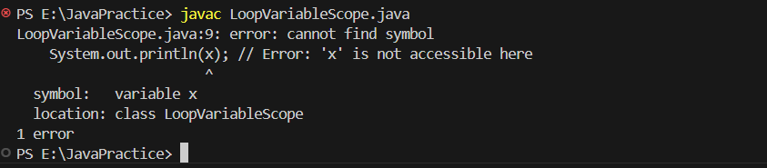

public class LoopVariableScope {
public static void main(String[] args) {
for (int i = 0; i < 5; i++) {
int x = i * 2;
System.out.println(x); // Error: 'x' is not accessible here

}
}
}

SECTION 2: Guess the Output
Snippet 1:
public class NestedLoopOutput {
public static void main(String[] args) {
for (int i = 1; i <= 3; i++) {
for (int j = 1; j <= 2; j++) {
System.out.print(i + " " + j + " ");
}
System.out.println();
}
}
}
// Guess the output of this nested loop.

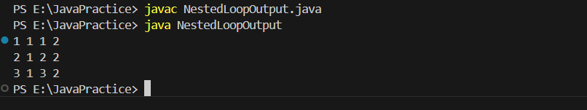

Snippet 2:
public class DecrementingLoop {
public static void main(String[] args) {
int total = 0;
for (int i = 5; i > 0; i--) {
total += i;
if (i == 3) continue;
total -= 1;
}
System.out.println(total);
}
}
// Guess the output of this loop.
